Chris Khan 2007
- Lewis Dot Structures consists of the symbols of the elements with dots and bonds, where each pair of dots is a lone pair and each line is a single bond, which consists of two electrons.
  - To write Lewis Dot Structures
    - Write the skeletal structure of the compound using chemical symbols
    - Calculate the total number of valence electrons, as in electrons on the outer shell (can be told by the group) and don’t forget to add electrons for a – charge and subtract them for a + charge
    - Place bonds between each ligand and the central atom
    - Complete the octets by adding lone pairs where necessary
    - If the central atom has <8 electrons, try adding double or triple bonds to complete the octets
- (Represent the Lewis Dot Structure of Barium hydride)→ BaH₂ has 4 electrons, so we draw a Ba in the middle (central atom) with a hydrogen on each side. There has to be a bond between the Ba and each hydrogen, which makes two total bonds, which represents 4 electrons.
  - H – Ba – H
- (Represent the Lewis Dot Structure of Carbon disulfide)→CS₂ has 16 electrons, so we draw a C in the middle (central atom) with a sulfur on each side. There has to be a bond between each Sulfur and the central Carbon, so that makes up for 4 electrons. Since we have 12 more, we have to add lone pairs. BUT, if we add 6 electrons to each Sulfur atom, Carbon won’t have an octet, so we make each bond a double bond and add two lone pairs to each Sulfur atom so the Sulfur atoms have 2 lone pairs and 2 bonds and the Carbon has 4 bonds, which is equal to 8 electrons.
.. ..
  - S = C = S
`` ``
- (Represent the Lewis Dot Structure of the Nitrite ion)→ NO₂⁻ has 18 electrons (remember to add one because of the – charge), so we draw a Nitrogen central atom with an Oxygen atom on each side. We add a bond between each oxygen and the central nitrogen, using 4 electrons and leaving us with 14. Since we can’t add 7 to each oxygen or 6 and give nitrogen one lone pair (since it won’t have an octet), we have to revert to double bonds. If we put a double bond between each oxygen and the central nitrogen, it just doesn’t work because then we can only use 16 electrons after putting 2 lone pairs on each oxygen, so we have to use only one double bond. By putting the double bond between one oxygen and the central nitrogen, we can put two lone pairs on that oxygen and three lone pairs on the other oxygen and put the last lone pair on top of the nitrogen atom. This way, each atom has an octet.
.. .. ..
  - O = N – O:
`` ``
- Like everything in life, there are exceptions. The exception to the octet rule occurs mainly in 2A, under categories of an incomplete octet, an odd number of electrons, or more than 8 valence electrons around the central atom. Elements in 3A, namely B & Al, tend to form compounds in which they are surrounded by <8 electrons.
..
- : F:
.. 1
: F – B (BF₃)
`` 1
: F:
``
    - The same case is for the AlI₃ molecule.
- BeF₂’s structure has 16 electrons, so we draw a Be central atom with two F atoms around it. We add the single bonds and 3 lone pairs to each F atom so we have
.. ..
- : F – Be – F:
`` ``
- What is the Lewis Structure of SF₄. Since it has 34 electrons and a S central atom with 4 F’s around it with 3 lone pairs each and one bond makes only 32, we have to add the last lone pair onto the S central atom.
- The VSEPR method accounts for the geometric arrangements of electron pairs around a central atom in terms of the electrostatic repulsion between electron pairs.
  - Two general rules
    - Double and triple bonds are treated like single bonds though multiply bonds are larger than single bonds
    - If a model has 2+ resonance structures, we can apply the VSEPR model to any one of them

Geometric Shapes
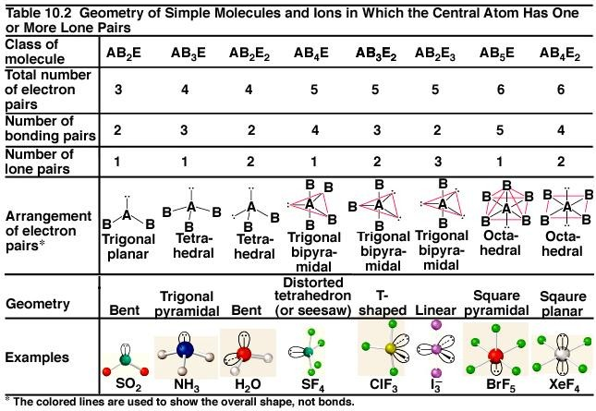

http://www.uwplatt.edu/~hamiltoj/chem145/vsepr.jpg

